CONFIGURATION MANAGEMENT
WHY:
The tools are flexible. One can have from three or four seats to hundreds of seats. It's applicable to large teams as well as small. However, companies shouldn't merely consider their size when hunting for Configuration Management tools. They must consider the complexity of the IT Infrastructure problem. The question is not a test of how big the shop is but how complex the management problem is. After all, companies can find themselves needing to grow or expand a unit rapidly. You need a tool that will meet your needs today but that will let you grow as well.

GOAL:
- Account for all the IT assets and configurations within the organisation and its services
- Provide accurate information on configurations and their documentation to support all the other Service Management processes
- Provide a sound basis for Incident Management, Problem Management, Change Management and Release Management
- Verify the configuration records against the infrastructure and correct any exceptions.

ACTIVITIES:

Configuration Management planning
A Configuration Management plan should define:
- The purpose, scope and objectives of Configuration Management
- Related policies, standards and processes that are specific to the support group
- Configuration Management roles and responsibilities
- CI (Configuration Item) naming conventions
- The schedule and procedures for performing Configuration Management activities: configuration identification, control, status accounting, configuration audit and verification
- Interface control with third parties, e.g. Change Management, suppliers
- Configuration Management systems design, including scope and key interfaces

Configuration identification
CIs are the components used to deliver a service. The CIs include software, documentation and SLAs
Also identify the relationship between CIs and the attributes for every CI.

Control of CIs
The objective of configuration control is to ensure that only authorised and identifiable CIs are recorded in the CMDB upon receipt.

Configuration status accounting
Status reports should be produced on a regular basis, listing, for all CIs under control, their current version and Change history. Status accounting reports on the current, previous and planned states of the CIs should include:

- Unique identifiers of constituent CIs and their current status, e.g. 'under development', 'under test', 'live'
- Configuration baselines, Releases and their status
- Latest software item versions and their status for a system baseline/application
- The person responsible for status change, e.g. from 'under test' to 'live'
- Change history/audit trail
- Open Problems/RFCs.

Configuration verification and audit
Service Desk staff, while registering incidents, can do daily verification.
Configuration audits should be considered at the following times:
- Shortly after implementation of a new Configuration Management system
- Before and after major Changes to the IT infrastructure
- Before a software Release or installation to ensure that the environment is as expected
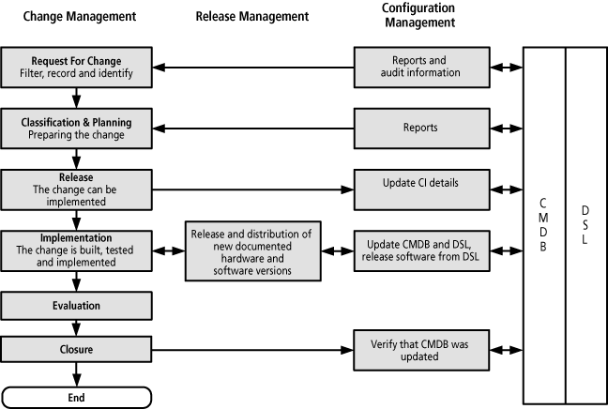
- Following recovery from disasters and after a 'return to normal' (this audit should be included in contingency plans)
- At random intervals
- In response to the detection of any unauthorised CIs
- At regular intervals

RESULTS:

Configuration Baseline (Complete overview of CIs and relationships)

Configuration plan

Configuration Management Database (CMDB)

Ongoing management of CMDB to support all other ITIL processes with accurate information on CIs and their relationship

COST:
Personnel – audit verification staff, database management team (Set-up and ongoing)
Accommodation – Physical location (Set-up and ongoing)
Software – Tools (Set-up and ongoing)
Hardware – Infrastructure (Set-up)
Education – Training (Set-up and ongoing)
Procedures – external consultants etc (Set-up)

The costs of implementing Configuration Management will be outweighed by the benefits. For example, many organisations cannot function satisfactorily unless they can handle a high volume of software and hardware Changes without sacrificing quality. Without adequate control, organisations are at risk from such things as computer fraud, inadvertent software corruption, software viruses and other malicious software. The damage caused by these can be enormous.
BENEFITS:

Providing accurate information on CIs and their documentation.

Controlling valuable CIs.

Facilitating adherence to legal obligations.

Helping with financial and expenditure planning.

Making software Changes visible.

Contributing to contingency planning.

Supporting and improving Release Management.

Improving security by controlling the versions of CIs in use.

Enabling the organisation to reduce the use of unauthorised software.

Allowing the organisation to perform impact analysis and schedule Changes safely, efficiently and effectively.
- Providing Problem Management with data on trends.

